# Lab 8. Interaction between Power Automate and Power Apps

**Author:** Serge Luca aka “Doctor Flow”

**Learning objective:** in many business scenarios, we need to have a PowerApps application calling a Flow.

**Updated:** 6/14/2020, based on the feedback received from Rishona Elijah.

**Duration:** 30 minutes

**Scenario:** you will create a PowerApps form that will allow any user to create a Team. The first part of the lab will just call a dummy Flow that you will create. If time permits, you will invoke the Team creation Flow that you will create later.

## Tasks

1. Create an instant Flow with From PowerApps as the trigger:

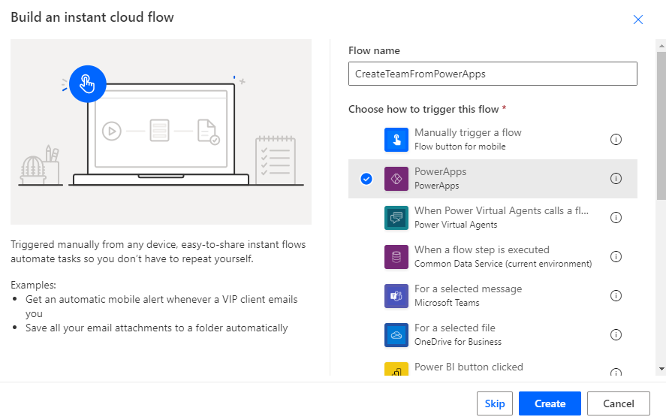

1. In this Flow, add 2 Compose actions and rename them accordingly:

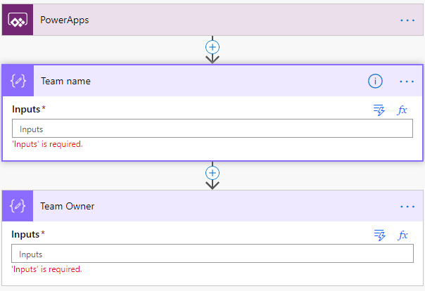

1. Link the Compose value to the Dynamic value **Ask in PowerApps**

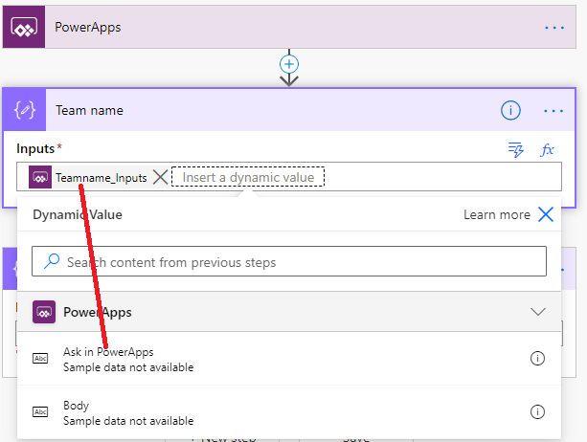

As you will notice, this generates new dynamic values based on the action name. So be very careful when you name your actions or variables because they will have an important impact on the parameter’s names of your flows.

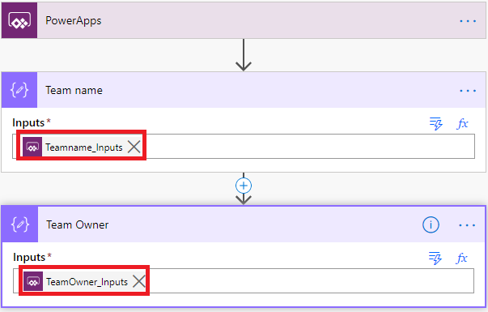

1. Add new **Compose** action, name it **Response** and set the Inputs to **Team created**:

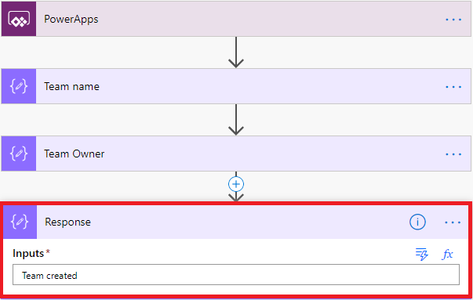

1. Add an action **Respond to PowerApps** that will return our response. Click Text as the output type:

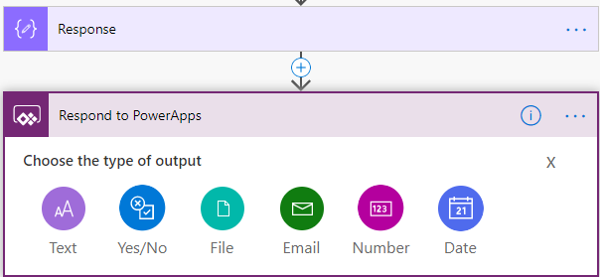

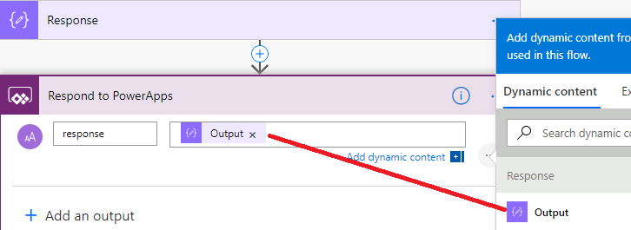

1. Save your Flow.
2. Now you will create a **PowerApps application** that will invoke our Flow. Go to **PowerApps.com**.

Click on Apps, menu Create an App

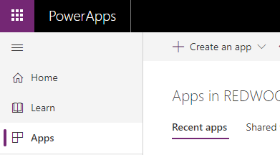

1. Select the **Canvas app**.
2. Click **Phone Layout**. The **PowerApps Designer** should show-up:

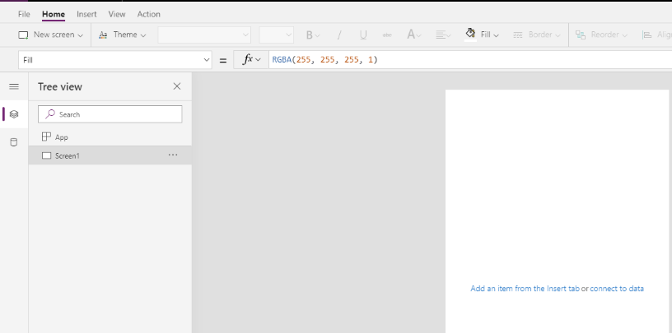

1. Add 2 labels, 2 textInput, and 1 button and rename them (**TextInputTeam** and **TextInputOwner**):

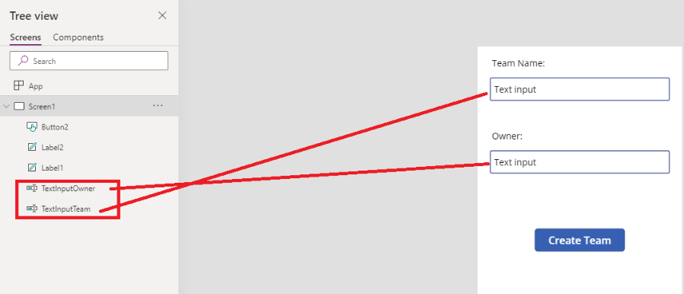

1. In the Action menu, click **Power Automate**:

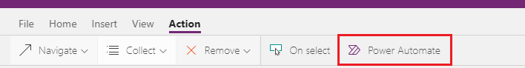

Click the Flow you want to invoke:

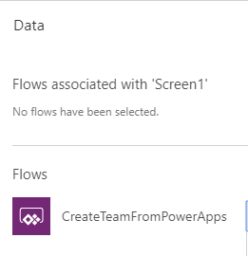

1. In the OnSelect property of the Button, call your Flow

**Set(Flowstatus, CreateTeamFromPowerApps.Run(TextInputTeam.Text, TextInputOwner.Text))**

[Note:

If you are using a non US version of Power Apps, the comma in the formula should become a semicolon ; the code becomes **Set ( Flowstatus, CreateTeamFromPowerApps.Run(TextInputTeam.Text; TextInputOwner.Text))**

]

1. Basically, the Flow returned value will be stored in a variable called **Flowstatus**.

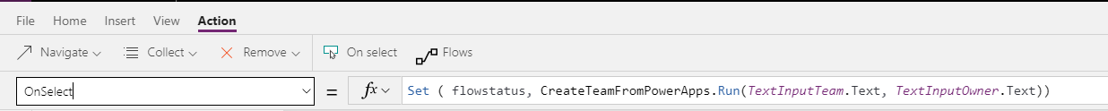

1. We will display the status in another label; add another label to the form:

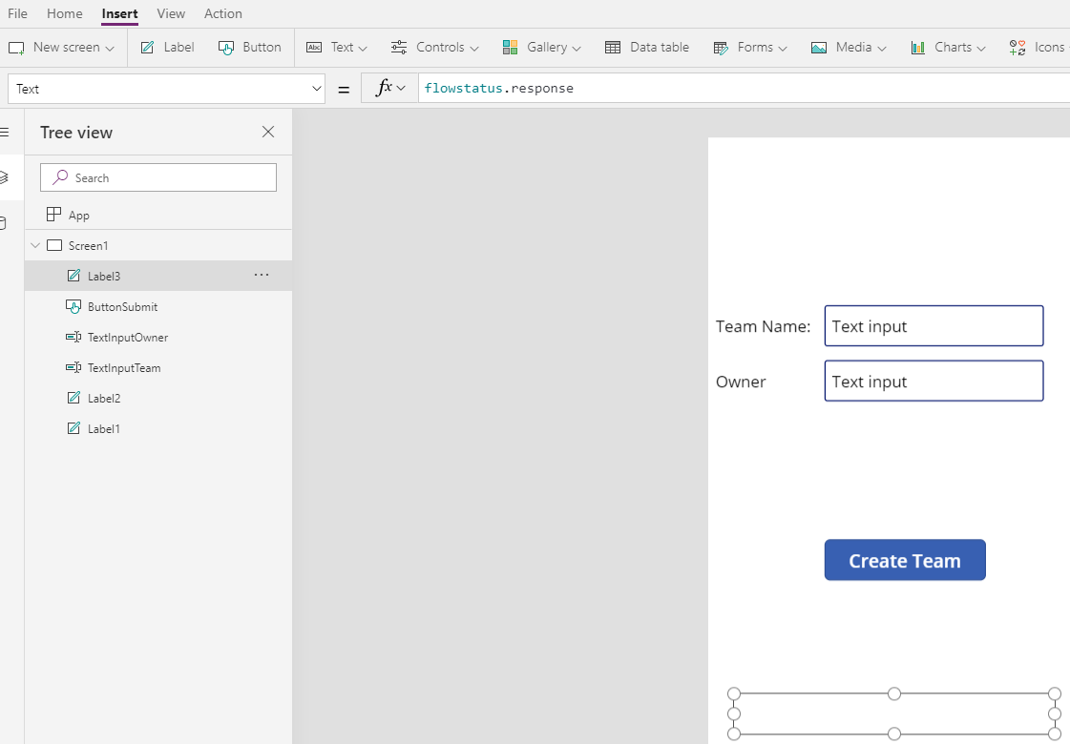

This new label Text property must be FlowStatus.response.

1. Run the Application, click the Submit button, and you should see the returned value:

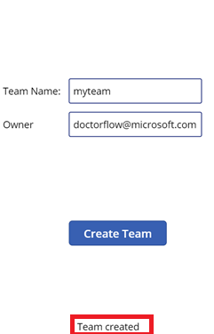

Now you can apply this knowledge to your real Flow to generate a real team.

## We need your feedback

Do you want to report an issue or to suggest something? We need your feedback: <https://github.com/Power-Automate-in-a-day/Training-by-the-community/issues>